Steps taken to interface Jetson Serdes Interface card with Ov10640 camera using Jetson TX2 board

- Installed Jetpack 3.3 with 28.2.1 and run JetPack-L4T-3.3-linux-x64_b39.run as an executable and flashed OS to Jetson TX2 development board.
- Ubuntu 16.04 is successfully installed in TX2 board hardware
- Tx2 board was connected to a separate monitor and in the TX2 board pc terminal, installed linux-image-4.4.38+d3-0.2.4+_1_arm64.deb and d3-tx2-util_0.2.4-1_all.deb D3 softwares.
- We have rugged version of Ov10640 camera and Jetson serdes Interface card, we choose the following DTB file , d3-ncic-ov10640_sigheader.dtb.encrypt and executed the following command in TX2 board pc terminal
      - sudo dd if= d3-ncic-ov10640_sigheader.dtb.encrypt of=/dev/mmcblk0p26
- After the drivers has been installed, sudo reboot was done to make the drivers effective.
- Again after powering off, interface card and camera are connected as per documentation
- Jumper is provided in the J13 for the first two pins out of three pins, No jumpers provided in the J14 as per the documentation. Camera connected to the J6 slot (third from the barrel connector edge). 12V Ac adapter was connected and card was interfaced with the jetson Tx2 board.
- After powering On, nvgstcapture command was executed to launch the camera application

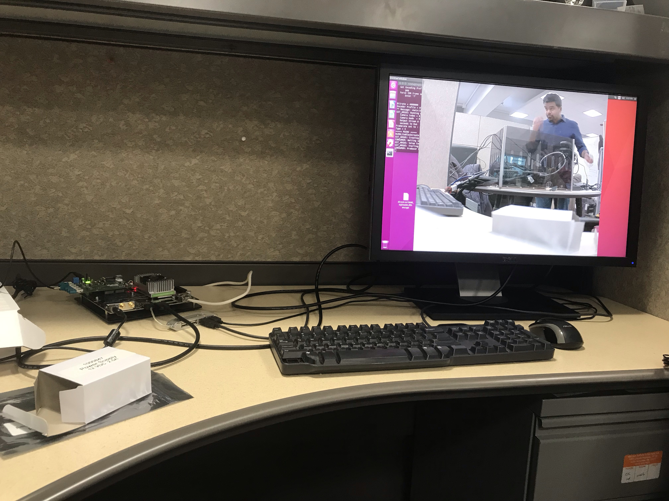

Appendix

- Jetson card interface with TX2 board

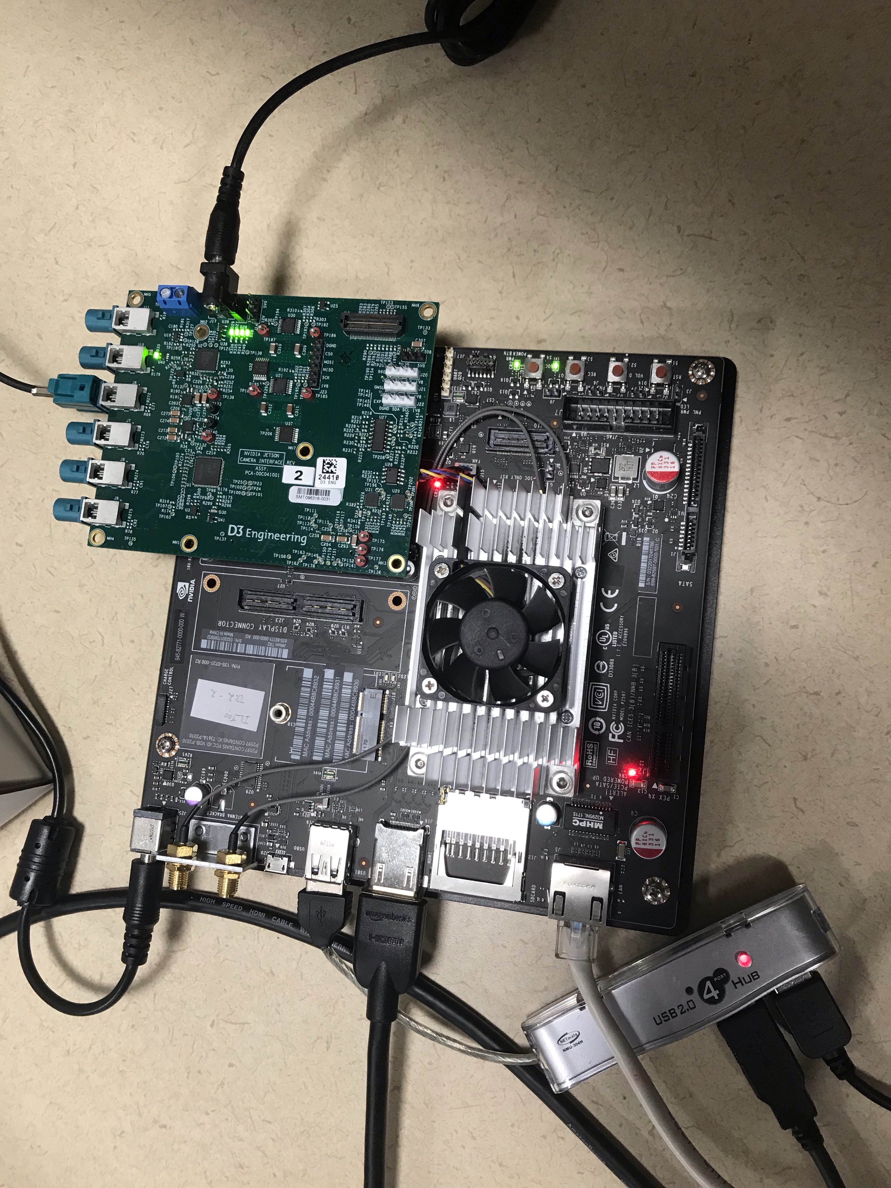

- After powering On, These LEDs should lit up if the DTB file is correct. Otherwise, it gets struck in boot-up screen.

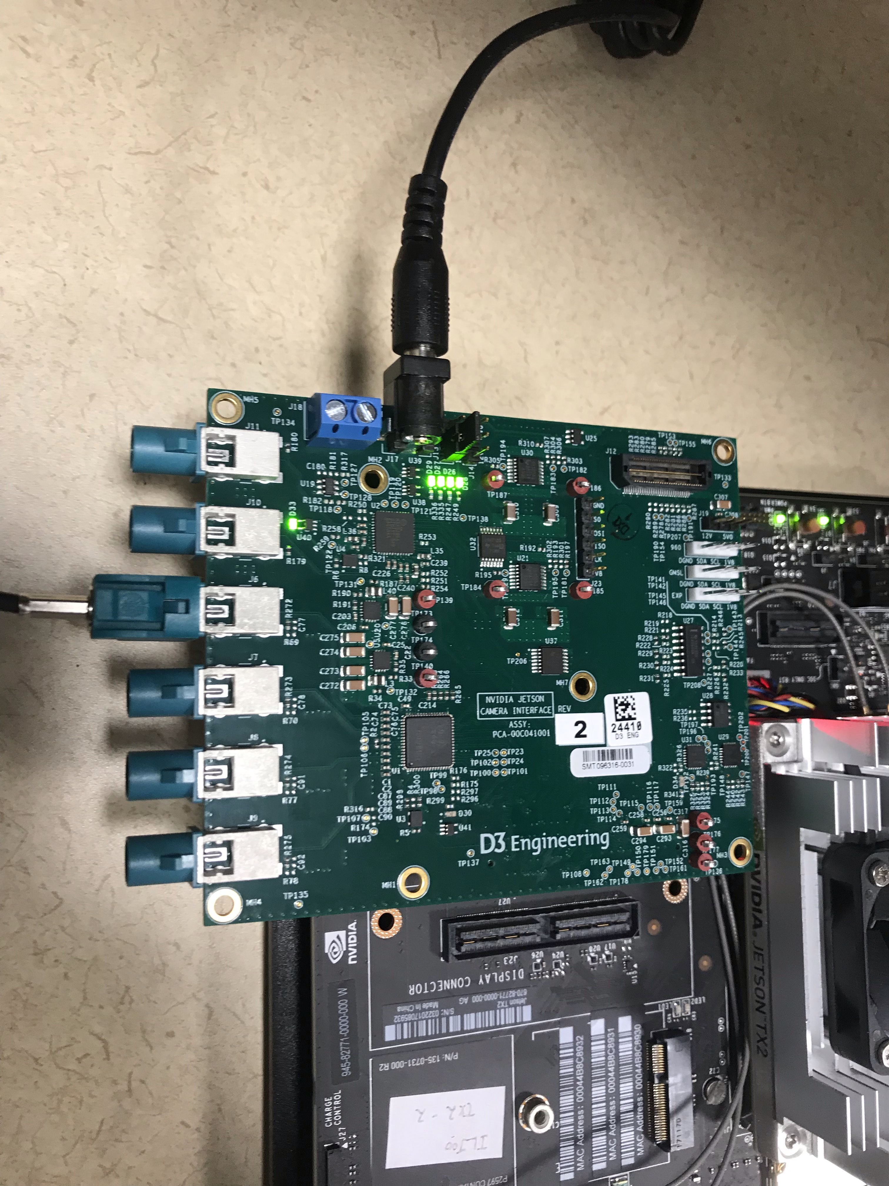
- Jumper J13 (Two input pins are jumper-ed) as per documentation.

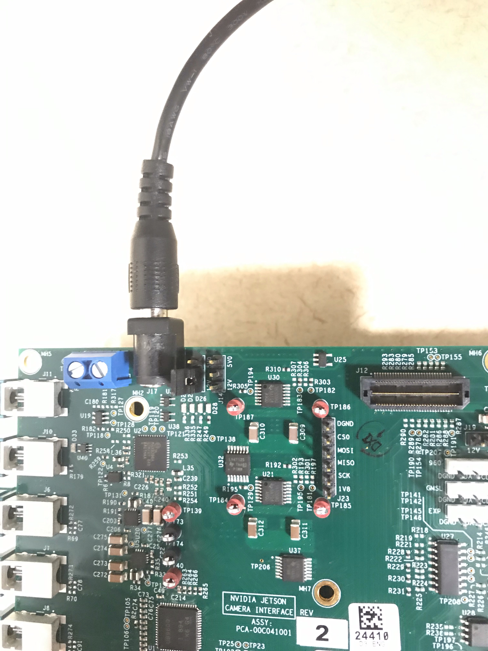

- We are using Ov10640 camera

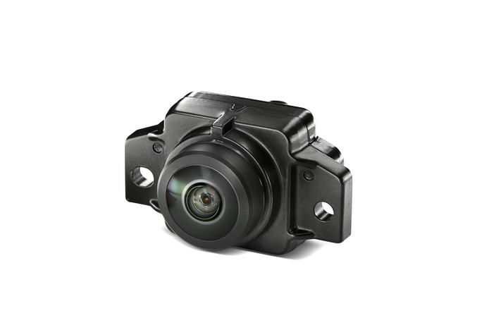

Instructions to record video:

1. Type nvgstcapture to launch camera

2. Type mo:2
- for launching video mode (type mo:2)
- for launching image mode (type mo:1)

3. Once in mode 2, Type 1 and press enter to start capturing video. You will see “ Recording Started, Enter (0) to stop OR (2) to take snapshot “ message

4. Type 2 whenever necessary to take snapshot while video is running

5. Type 0 to stop the recording

6. Type quit to exit the camera application.

Instructions for changing the resolution of the camera

- While launching the camera application, use
  - nvgstcapture --video-res=3 (for resolution 1280 X 720 )
  - change the number based on the supported resolutions
  - for changing image resolutions, use argument --image-res=3

Supported resolutions in case of ARGUS Camera
(2) : 640x480
(3) : 1280x720
(4) : 1920x1080
(5) : 2104x1560
(6) : 2592x1944
(7) : 2616x1472
(8) : 3840x2160
(9) : 3896x2192
(10): 4208x3120
(11): 5632x3168
(12): 5632x4224

